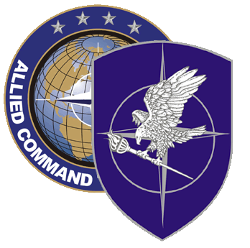
NATO SCHOOL: Global Leader in Multinational Military Education and Individual Training

N-9-89 NATO JOINT MARITIME MEDICAL Staff Course [JMARMEDS]

As a course under the control of MEDNEP, the aim of this course is to provide basic knowledge of all areas of Joint Maritime Medical planning.
The course is specially designed for Joint Maritime Medical Planners and Medical Advisors in a Task Group-/Task Force [TG/TF] formation as well as those working at the Tactical and Operational Maritime Component [MC] level.
Students will be enabled to plan Medical Support and to provide Medical Advice to Commanders in a Maritime Environment. This includes NATO standing Naval Formations, NATO Peacetime HQ’s, NATO-Operations, and others.
Staff Officers dealing with JOINT MEDICAL Support Planning within a Maritime Environment at highest national MOD-national Operations Command level will benefit by using the same NATO understanding for MEDICAL Support. MEDNEP will continually review, update and approve any changes to this course.

Course Length: 1 week

Offerings per year: 1

Class Size: 2012 (pilot): 25 max/ min 15 x [10.-14. Dec 2012]
2013: 35 max/ min 15 x [02.-06. Dec 2013]

Security Clearance: NATO RESTRICTED

Rank Limitation: OF-2-OF-5
Any military member of the rank OF-2 through OF-5 or their civilian equivalents in NATO countries in a Medical Support role are welcome.
Course recommendation is for OF-2 to OF-4.
Senior NCOs in a prominent Medical Support role within MC/HQ can apply for a rank waiver.

Prerequisites:

a) Language proficiency: English IAW STANAG 6001 3333

b) Computer skills: Student must be familiar with MS Word and Power Point.

Course Objectives:

At the completion of the course the student should:

- Understand the NATO Structure in general and the NATO Maritime Medical Structure in detail.
- Conduct basic Medical Planning in a mainly Maritime Environment including MEDEVAC-Planning at all levels.
- Manage the Recognized Maritime Medical Picture.
- Understand Medical interaction with the Chain of Command.
- Provide Medical Ethical Advice to Commanders.
- Understand Medical Aspects of the Management of the Dead.
- Conduct post operational staff work.
- Perform duties in a Maritime Environment as Medical Adviser or Medical Planner at TG/TF level.

